LAB Logbook

Lab 1 -

Lab 2 –

Lab 3-

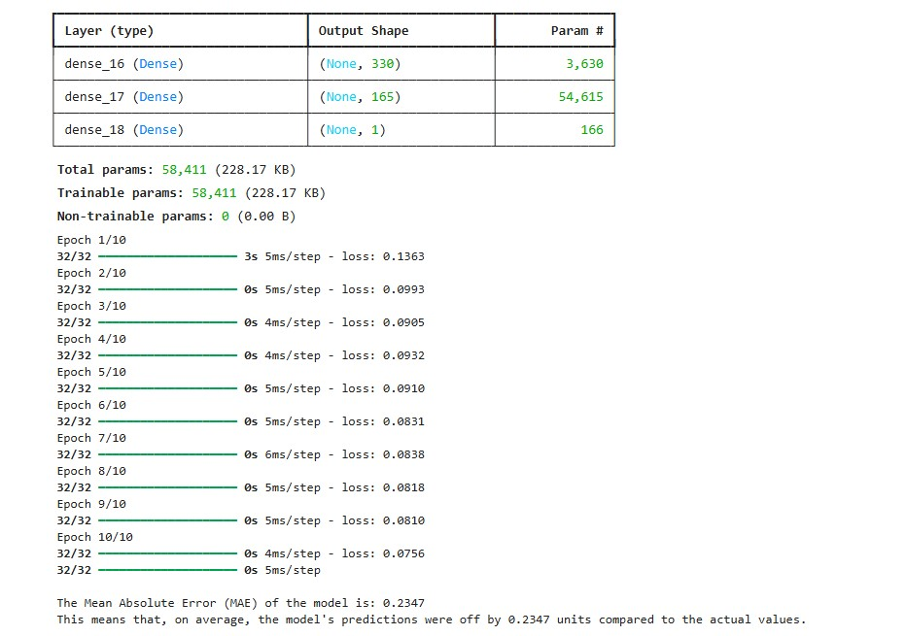

Lab 5 –

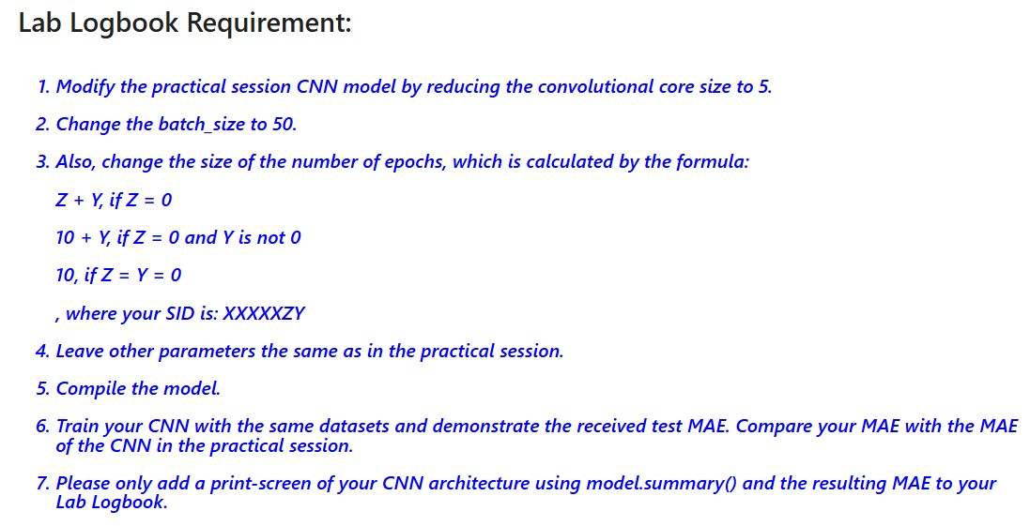

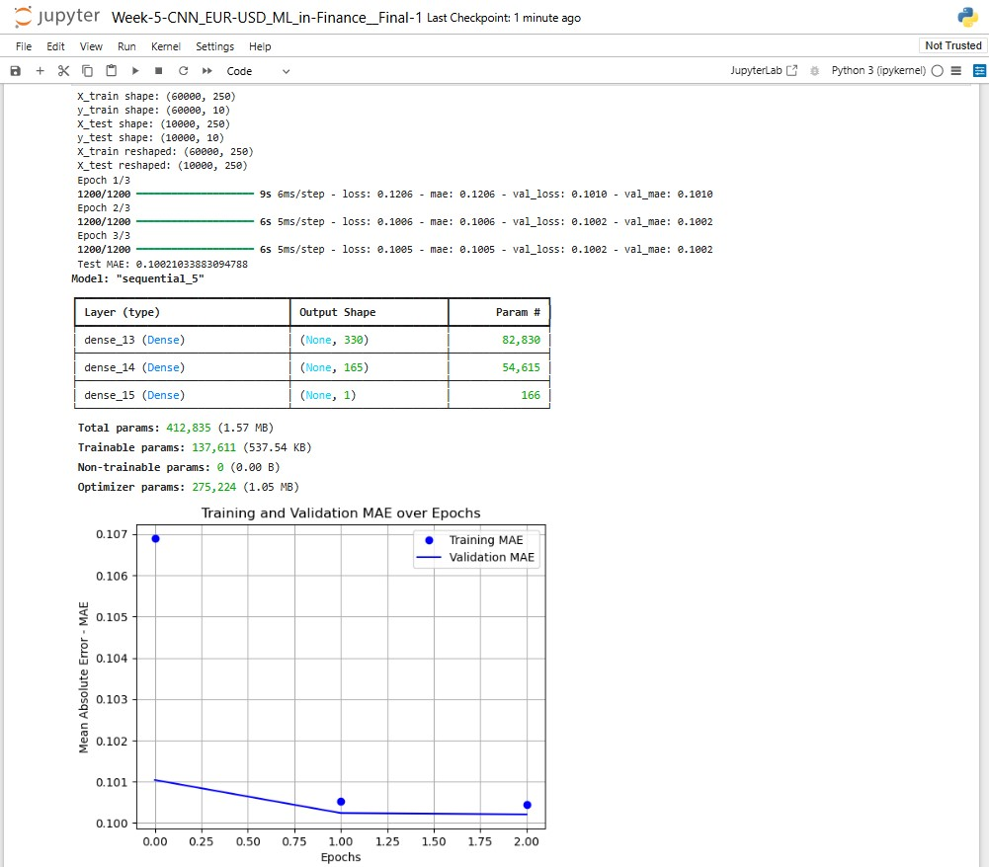

Lab 6

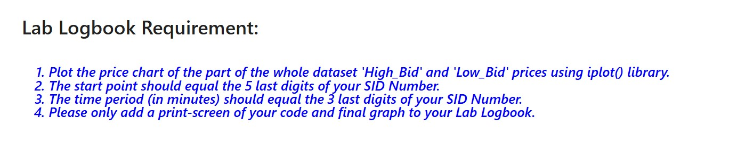

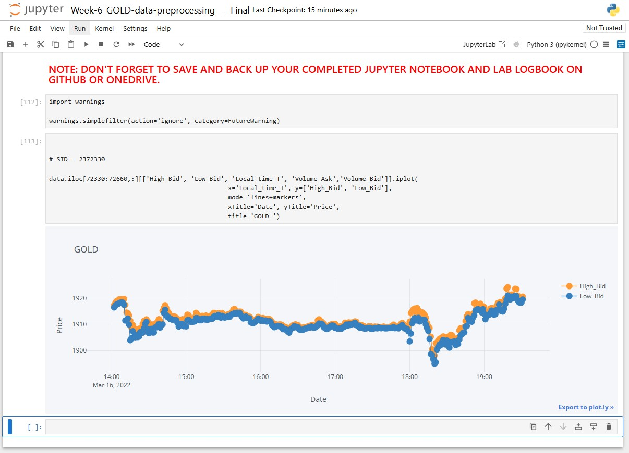

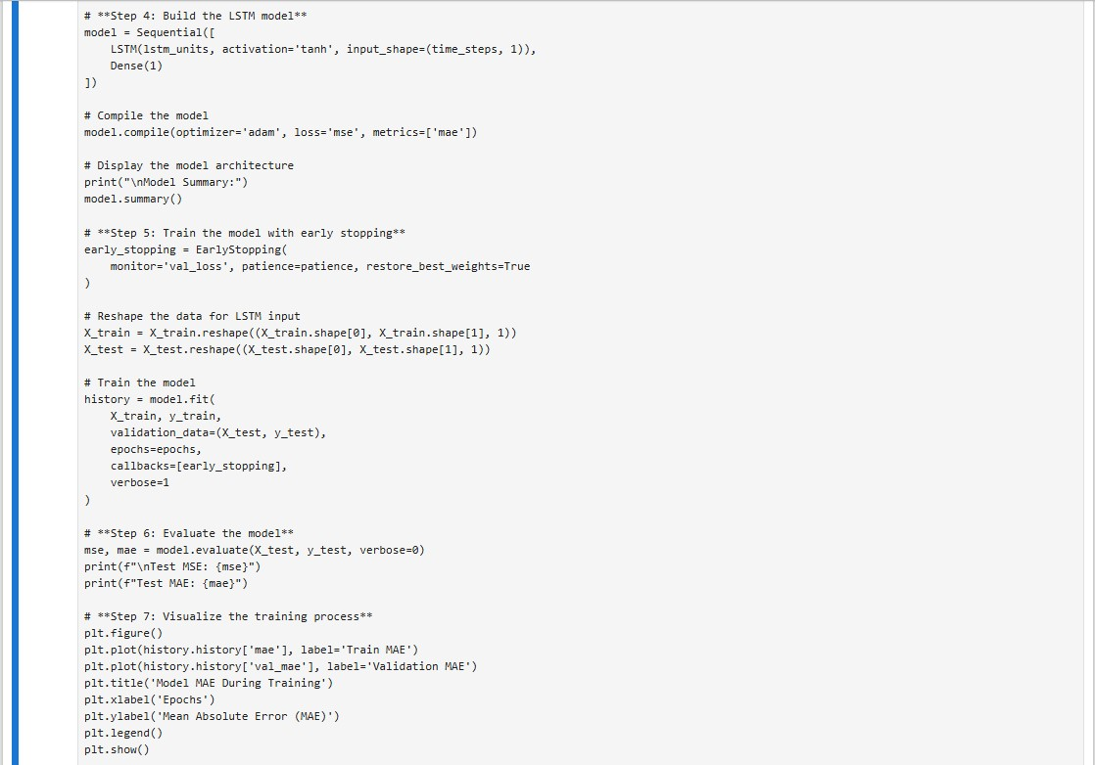

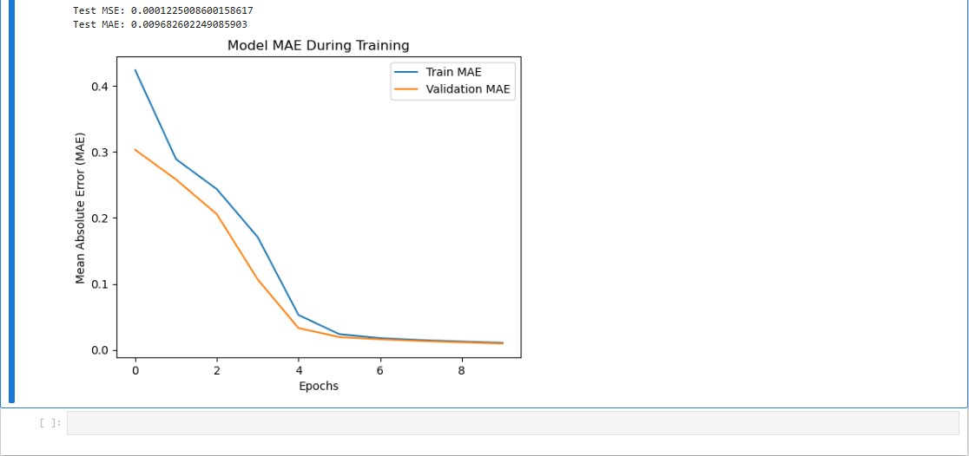

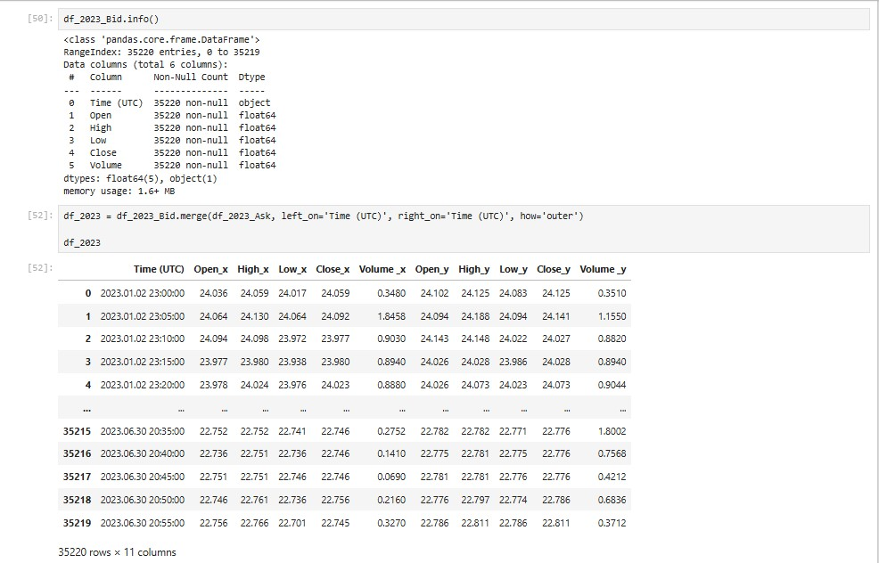

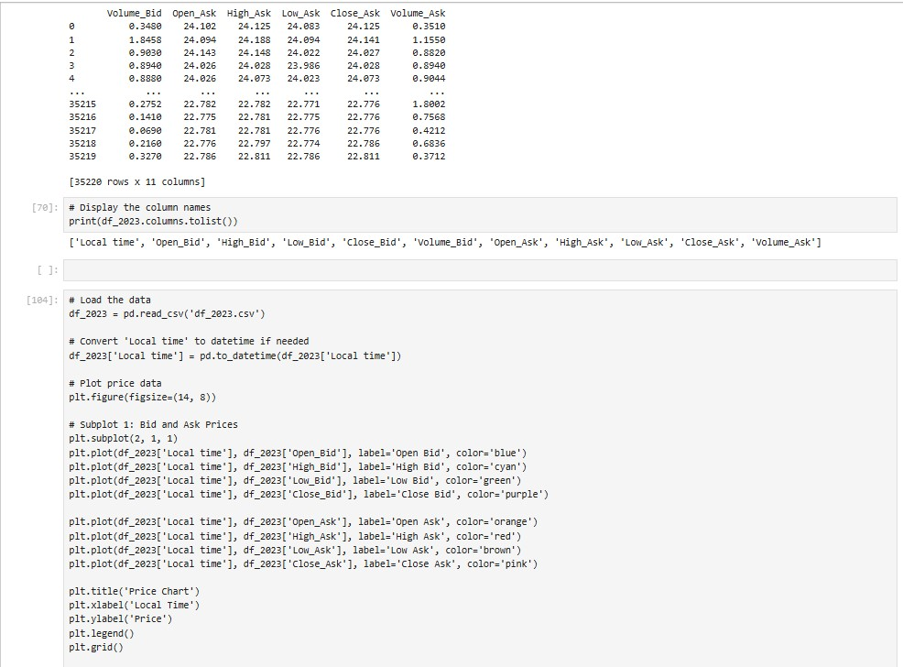

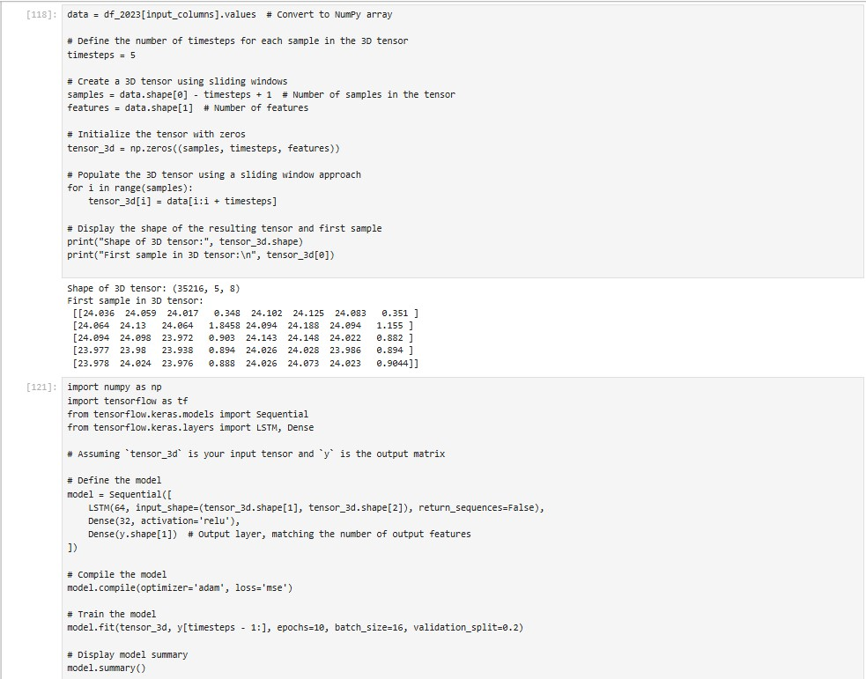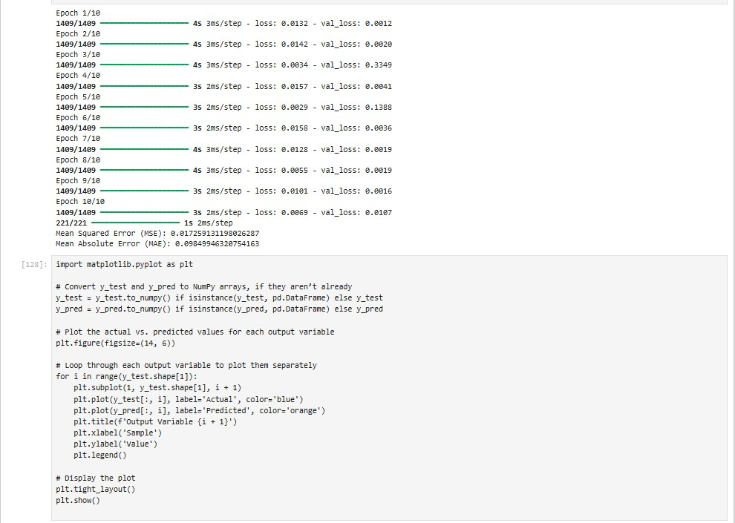

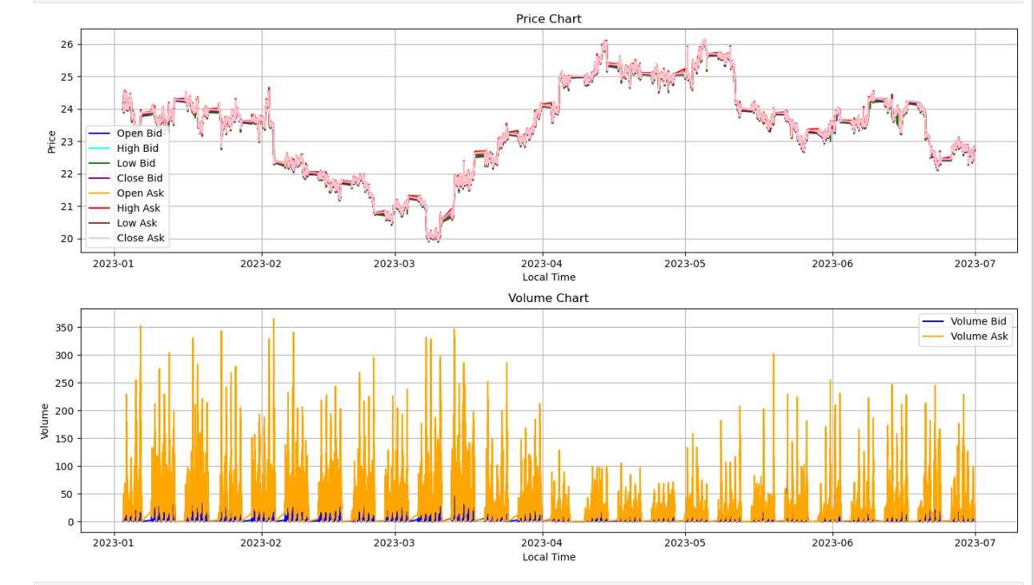

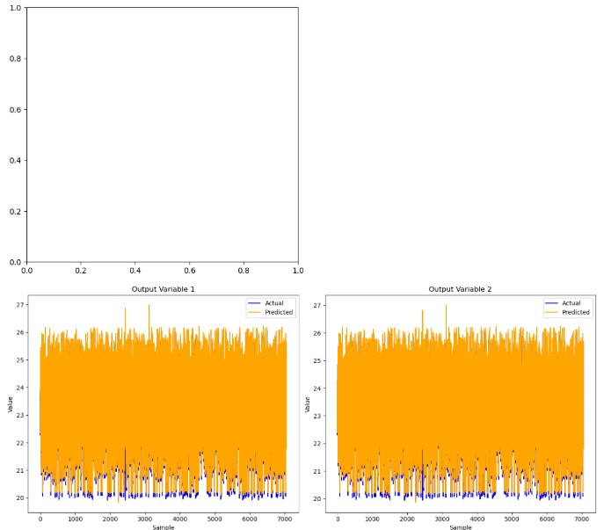

Lab 9

Lab 10

Lab 11

Lab 12